**UI/UX Technical Document - Mini Dashboard (Berlin District)**

# 1. Purpose & Scope

This document defines the **UI/UX design specifications** for the Mini Dashboard.  
 It covers:

* **Landing page** (onboarding)
* **General View** (default, compact).
* **Expanded View** (detailed insights).

The goal is to:

* Provide clarity on **layout, interactions, KPIs, and charts**.
* Ensure engineers can replicate the dashboard in a consistent and reproducible way.
* Enable users to **explore Berlin districts**, compare living conditions, and make data-informed decisions.

# 2. Landing page

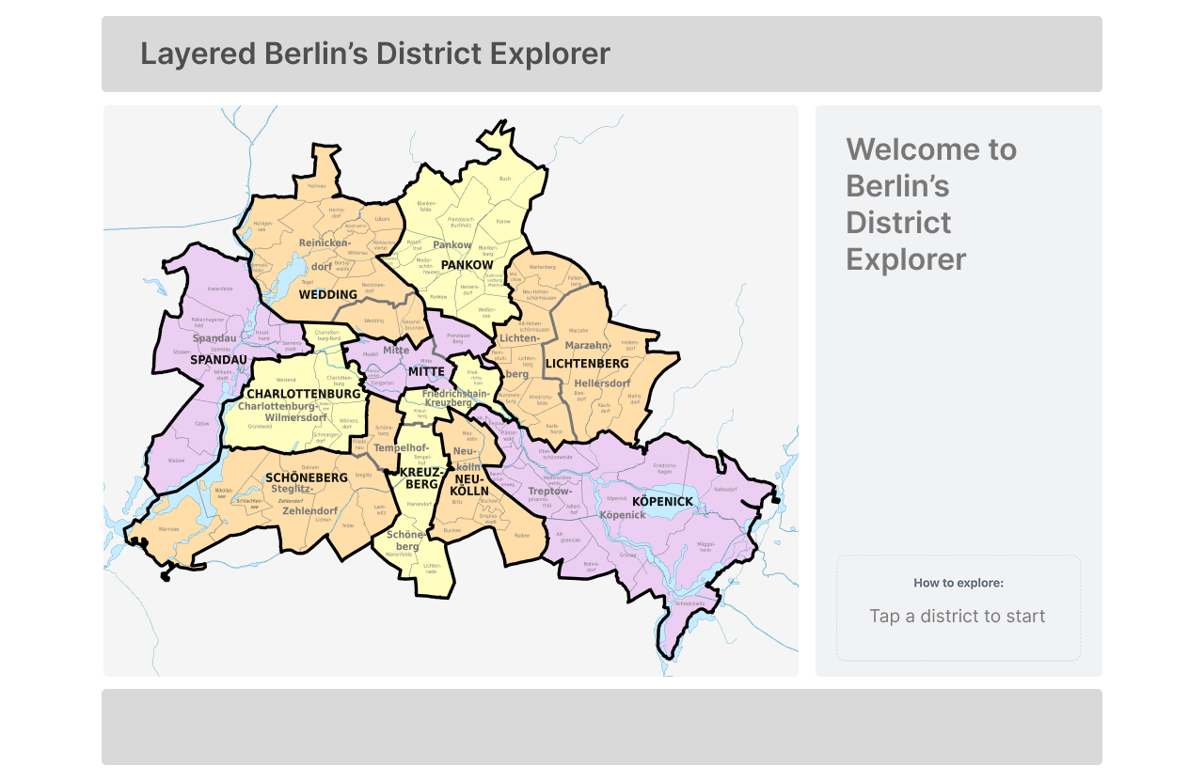

* **Top Bar**: Title
* **Side Bar**: Welcome message and onboarding instructions
* **Map:** Clickable districts map of Berlin

# 3. General View

### **Objective**

The General View provides a quick, at-a-glance overview of Berlin districts.

* **What we are doing:** Showing a map-based navigation with lightweight KPIs.
* **How we are doing it:** Using an interactive SVG map connected to a collapsible District Info Panel.  
  **Why it helps:** Users can scan, filter, and select districts without being overloaded with details. It supports **fast exploration** and acts as the **entry point** to deeper insights.

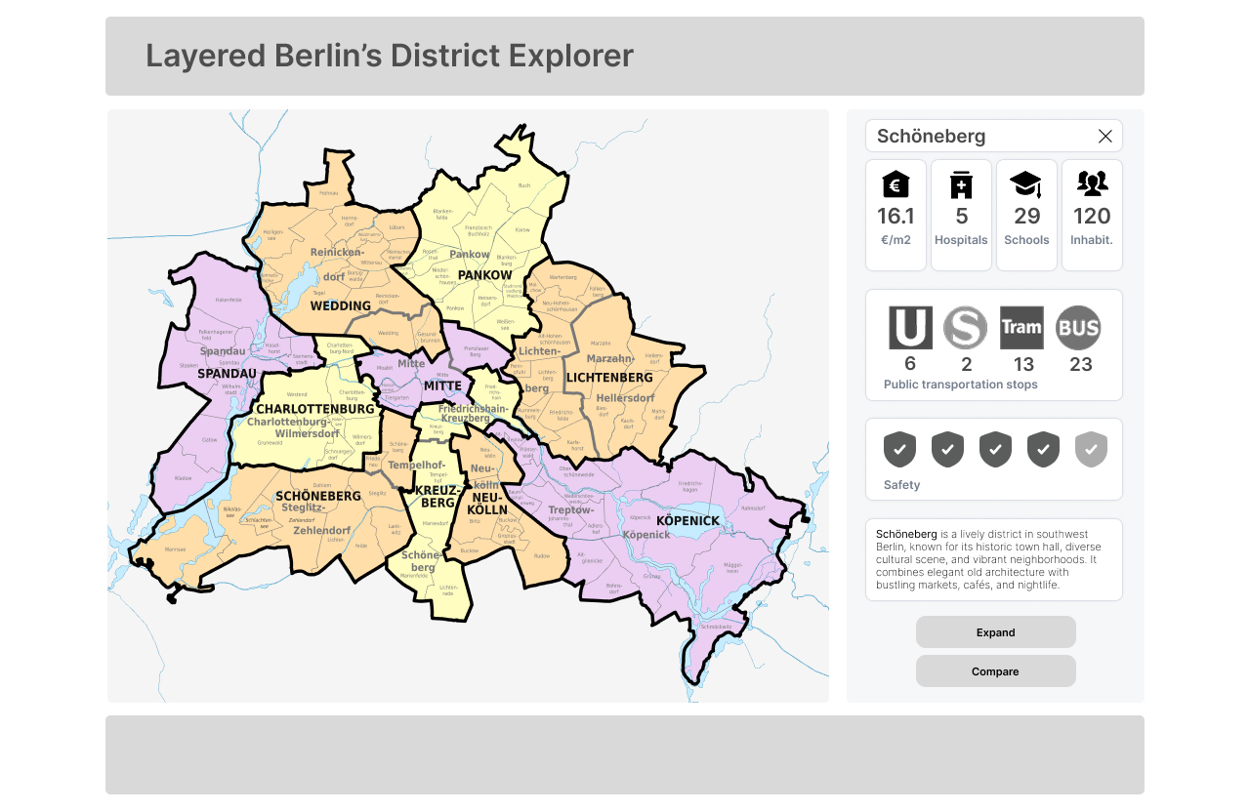

* **Title:** “Berlin District Explorer” or similar
* **Side bar:** mini dashboard with general first overview about the districts
* **Map:** Clickable

## **3.1 The general view dashboard** The District Info panel is a key component of the dashboard's **General View**, designed to provide users with a quick, at-a-glance summary of a selected district. This panel changes dynamically based on the user's interaction with the map, providing essential metrics and a brief overview. It acts as the primary entry point to deeper insights about the district.

### 3.1.2 - Sidebar Elements

**3.1.2.1 Header:** District name  
  
The panel's header displays the name of the currently selected district. When a user clicks a district on the map, the header immediately updates to reflect the chosen district's name.

**3.1.2.2 KPI Cards:** rent, schools, hospitals, population.

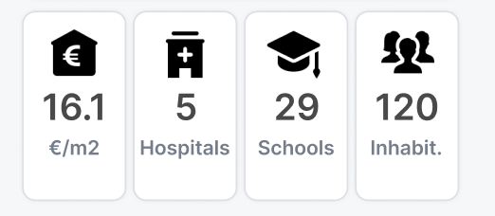

These are the key performance indicators (KPIs) presented as visual cards, each representing a different aspect of a district's living conditions. The data for these cards is pulled from the **Tables Used** and **Key Fields** shown in the provided spreadsheet.

* **Rent:** The average rent per square meter for the district. The value is calculated using data from the **short_time_listings** and **long_term_listings** tables, specifically the **price** and **sqm** fields.
* **Hospitals:** The count of hospitals within the district. This data is sourced from the **hospitals** table, using the **hospital_name** field.
* **Schools:** The number of educational institutions in the district, including schools, kindergartens, and universities. This metric is derived from the **schools** and **universities** tables using the **name** and **type** fields.
* **Population:** The total population of the district. This information is a key metric from the **districts_pop_stat** table, using the **population** field.

**3.1.2.3 Public transportation stops:** sum of stops of each modal

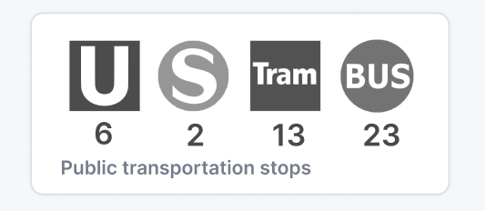

This card shows for each modal (U-Bahn, S-Bahn, Tram, Bus) the number of stops in the district. These can be counted with the table.

**3.1.2.4 Safety score:** The safety score shows how secure each district is compared to the rest of Berlin. Districts are rated on a **1–5 scale**, where **5 shields = safest** and **1 shield = least safe**.

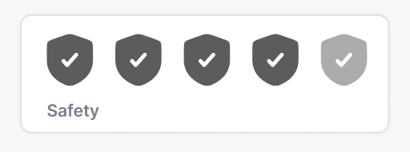

The score is based on crime statistics, combining how often crimes occur with their severity, then comparing districts against each other.

**3.1.2.5 Text overview:** briefly describes the district. Generated by LLM, added to column ‘text_description’.

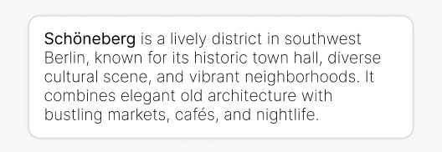

**3.1.2.6 Expand or compare:** optional depth analysis



Here the user can expand the dashboard to get more detailed information about the districts. Comparison is to be detailed on next iterations.

# 4. The expansion

**Wireframe**

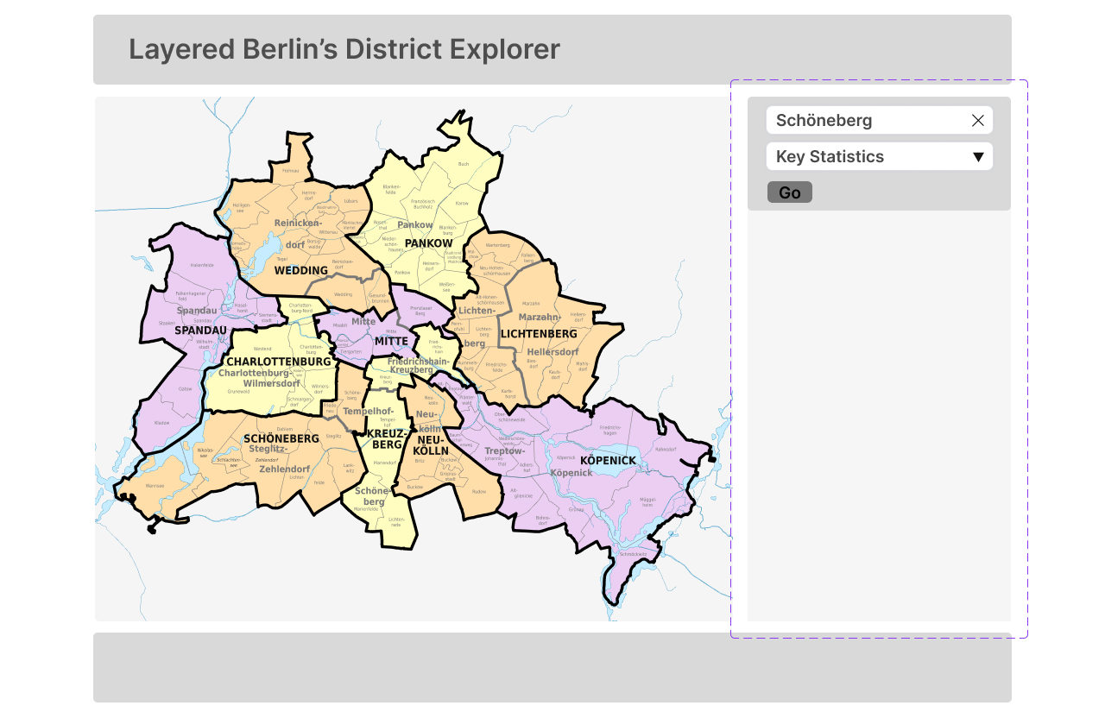

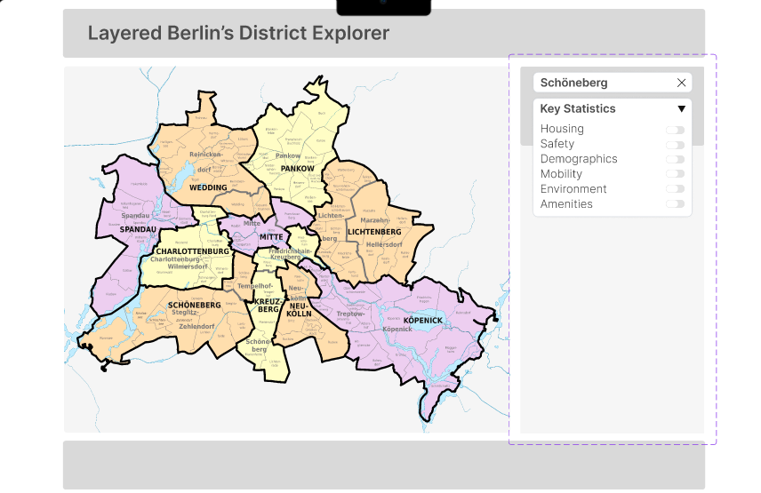

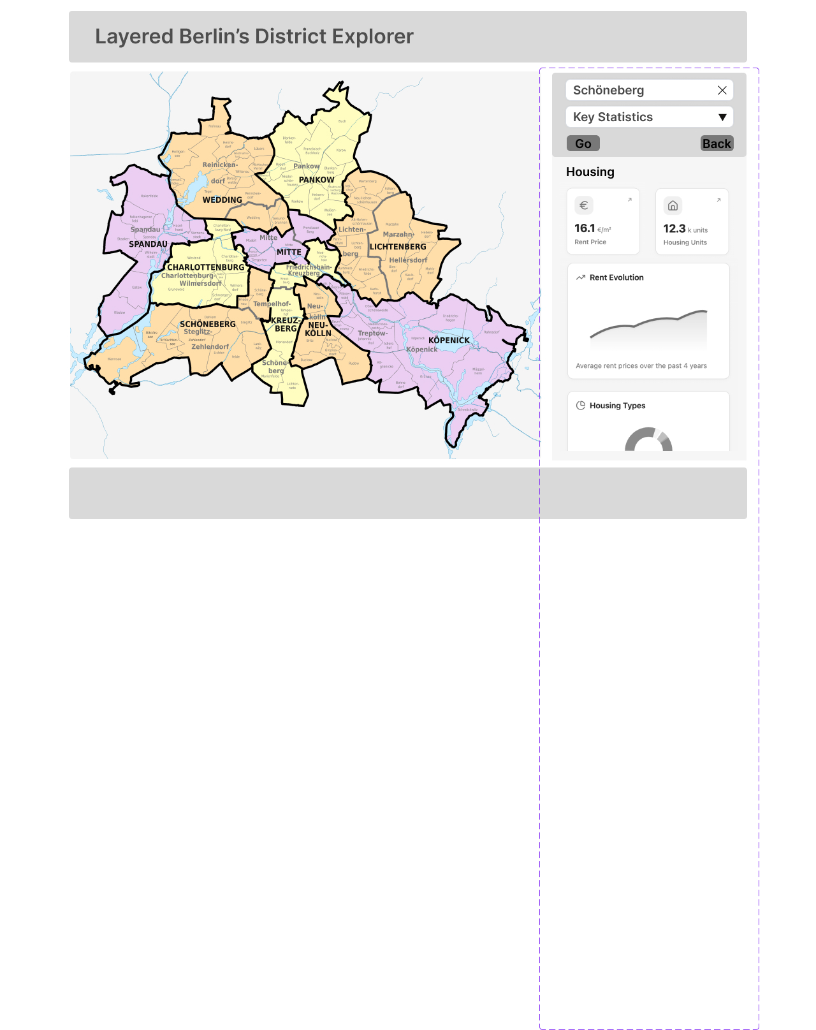

## 4.1 - Category Toggles

After a district is selected, a **category toggle** (dropdown) is displayed on the side bar section. Categories include:

* Housing
* Safety
* Demographics
* Transport & Mobility
* Environment
* Amenities

Selecting a category filters the displayed content so the user only sees the charts and KPIs relevant to that category. This reduces information overload and makes the dashboard easier to navigate.

**4.1.1 - Housing**

The dashboard will visualize rent data using a combination of chart types to provide a comprehensive overview.

1. **Time-Series Line Chart:** This chart shows the **average rent per square meter ($/sqm)** over time. It allows users to identify trends, such as increasing or decreasing rental costs, and compare the current rent to historical data. The x-axis represents time (e.g., months or quarters), and the y-axis represents the average rent.

**Chart Title:** "Average Rent Over Time"

**X-Axis Label:** "Date" (e.g., Month, Quarter, or Year)

**Y-Axis Label:** "Average Rent per SqM (€)"

**Tooltip:** On hover, show "Date: [Date]", "Average Rent: [€value]", and "Change from Previous Period: [+/- %]".

**Annotation:** Add an annotation for significant events that may impact rent prices, such as a major policy change or a new development.

**Highlighting:** Highlight the most recent data point to draw attention to the current average rent. In the comparison view, use different colors to distinguish the two districts and highlight the area where the two lines diverge significantly.

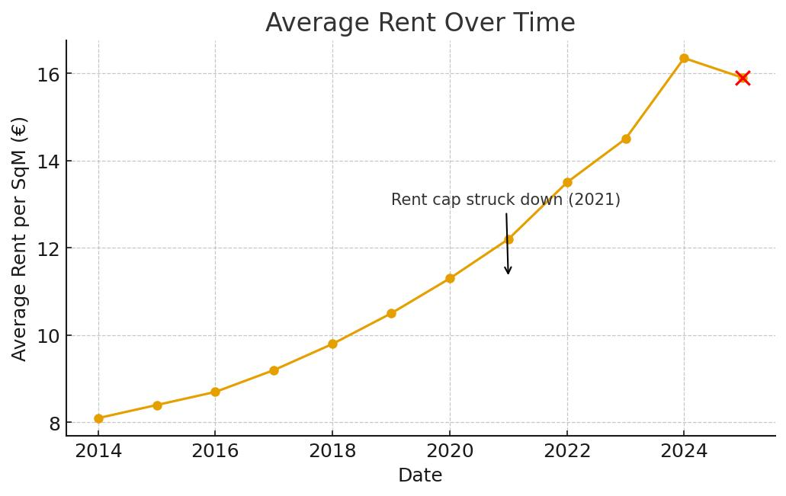

1. **Bar Chart:** This chart can be used to compare the **average rent of the selected district** to the Berlin average and to other districts. It provides a clear, categorical comparison of rental costs across different areas.

**Chart Title:** "Rent vs. Berlin Average"

**X-Axis Label:** "Location" (e.g., "Mitte", "Berlin Average")

**Y-Axis Label:** "Average Rent per SqM (€)"

**Tooltip:** On hover, display "Location: [District Name]", "Average Rent: [€value]".

**Highlighting:** Use a distinct color for the selected district's bar to make it stand out. A lighter shade or a different texture can be used for the Berlin average bar.

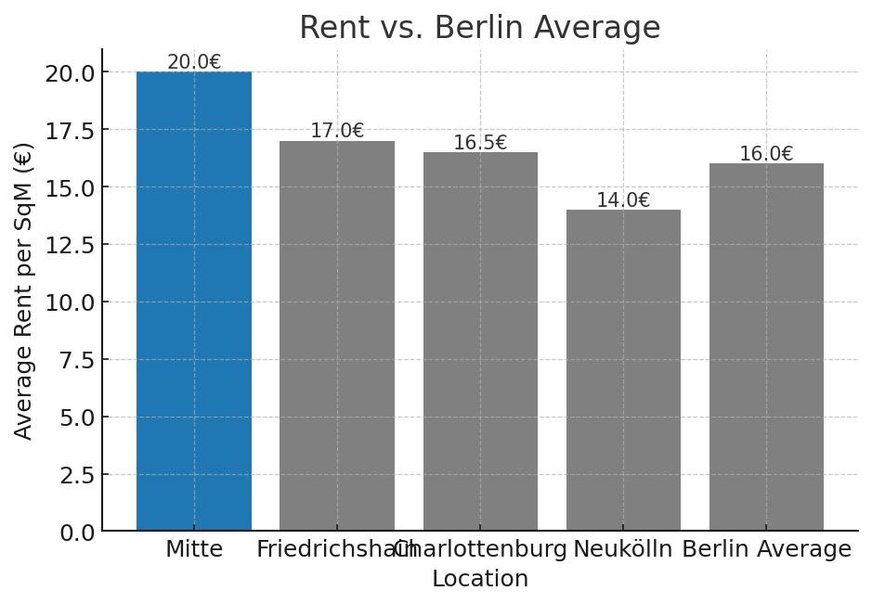

1. **Pie Chart :** This chart presents distribution of apartment sizes (1–2 rooms, 3–4 rooms, 5+ rooms) with annotations showing the **average monthly rent (€ / month)** for each category. It conveys both the relative availability of each apartment size and the expected monthly housing cost, giving a fuller picture of affordability in the district.

**Chart Title:** "Apartment Size Availability in Mitte (with Avg Rent per Month)"

**Legend / Categories:** "1–2 rooms", "3–4 rooms", "5+ rooms"

**Tooltip (in an interactive setting):***"Category: [Room Range]", "Listings: [Count]""Avg Rent per Month: [€value]"*

**Highlighting:** Distinct colors are applied to each slice, and average monthly rent values are displayed within the chart for clarity.

## 

## 

## **4.1.2. Safety**

The safety score will be presented with charts that illustrate crime data in detail.

1. **Stacked Bar Chart (Safety Score Components):** A stacked bar chart can show the **factors contributing to the overall safety score**, such as crime rate per capita, police presence, and community programs. This breaks down the composite score and provides transparency.

**Chart Title:** "Safety Score Breakdown"

**X-Axis Label:** "Contributing Factor" (e.g., "Crime Rate per Capita", "Police Presence")

**Y-Axis Label:** "Score Contribution"

**Description:** This chart provides transparency by breaking down the overall safety score into its **constituent components**. It shows which factors contribute most to the final rating.

**Tooltip:** On hover, show "Factor: [Factor Name]", "Contribution to Score: [Value]". The total height of the bar would represent the final safety score.

**Highlighting:** Use different colors for each component to make it easy for users to identify and compare the factors. In a comparison view, stack the components for each district side-by-side.

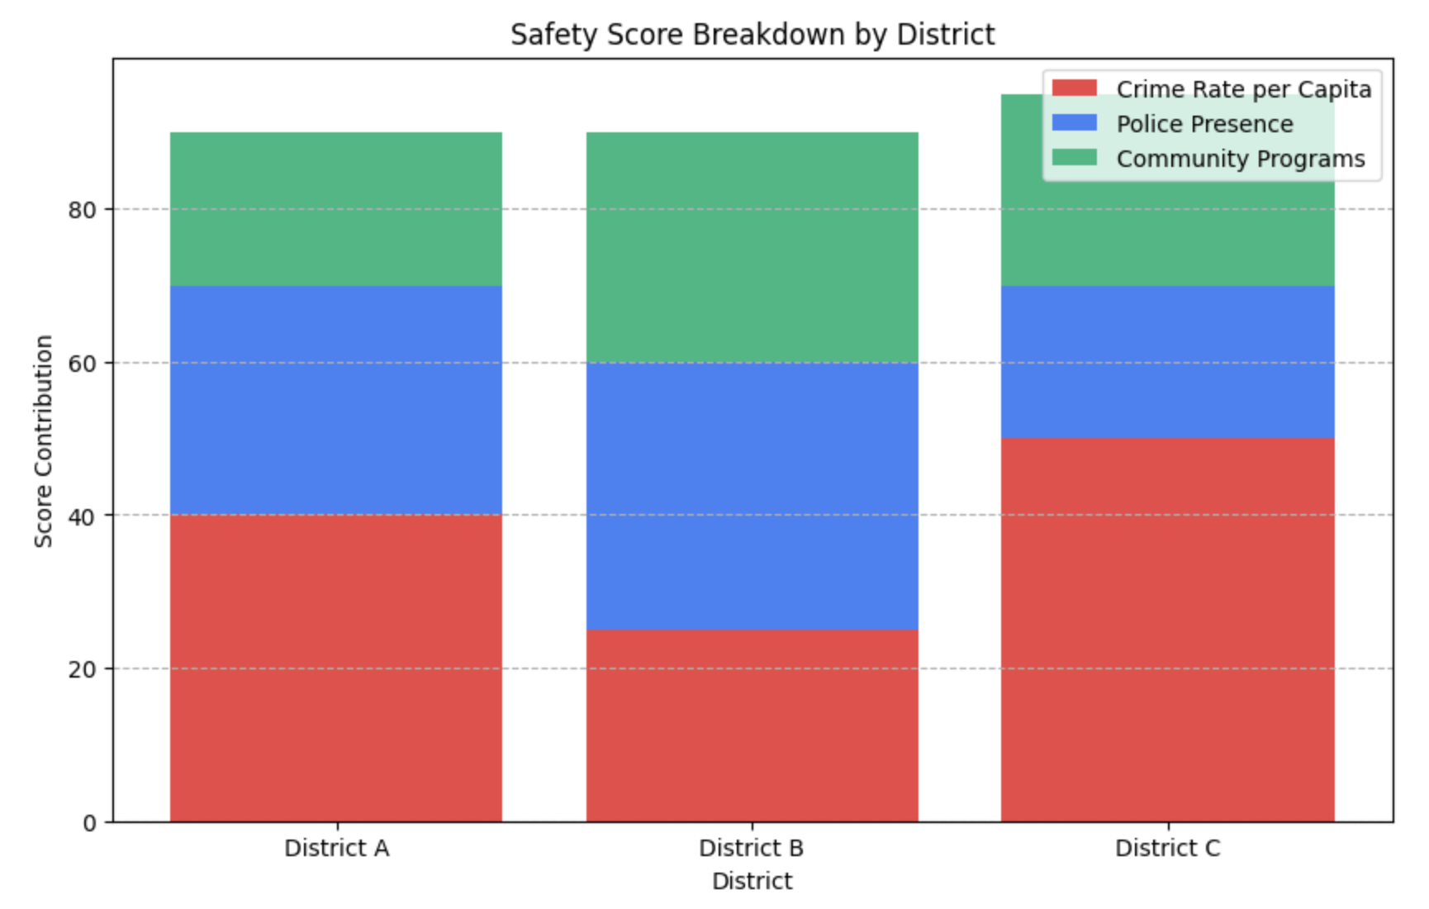

1. **Bar Chart (Crime Type Breakdown):** A bar chart to display the **breakdown of crime incidents by type** (e.g., property crime, violent crime, etc.). This helps users understand the nature of the crimes that are most prevalent in the district.

**Chart Title:** "Breakdown of Crime Types"

**X-Axis Label:** "Crime Type" (e.g., "Property Crime", "Violent Crime")

**Y-Axis Label:** "Number of Incidents"

**Tooltip:** On hover, show "Crime Type: [Type]", "Incidents: [Number]", and "Percentage of Total: [%]".

**Highlighting:** Order the bars from highest to lowest incident count to immediately show the most prevalent crime types.

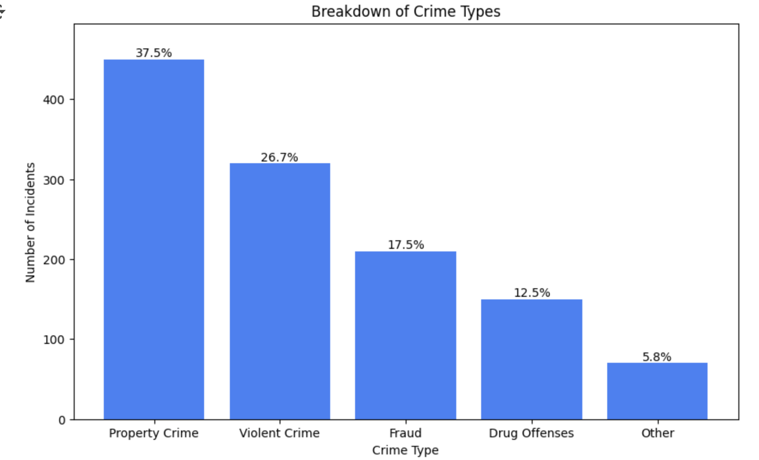

1. **Time-Series Line Chart (Crime Incidents):** A line chart to track the **number of reported crime incidents over time**. This helps users see if the district is becoming safer or less safe and identify any seasonal or long-term trends. The x-axis represents time, and the y-axis represents the number of incidents.

**Chart Title:** "Crime Incidents Over Time"

**X-Axis Label:** "Date"

**Y-Axis Label:** "Number of Incidents"

**Tooltip:** On hover, display "Date: [Date]", "Total Incidents: [Number]".

**Annotation:** Add annotations for any notable fluctuations or trends, such as "Decrease due to local police initiative".

**Highlighting:** Use a different color to highlight the line representing the selected district in the comparison view.

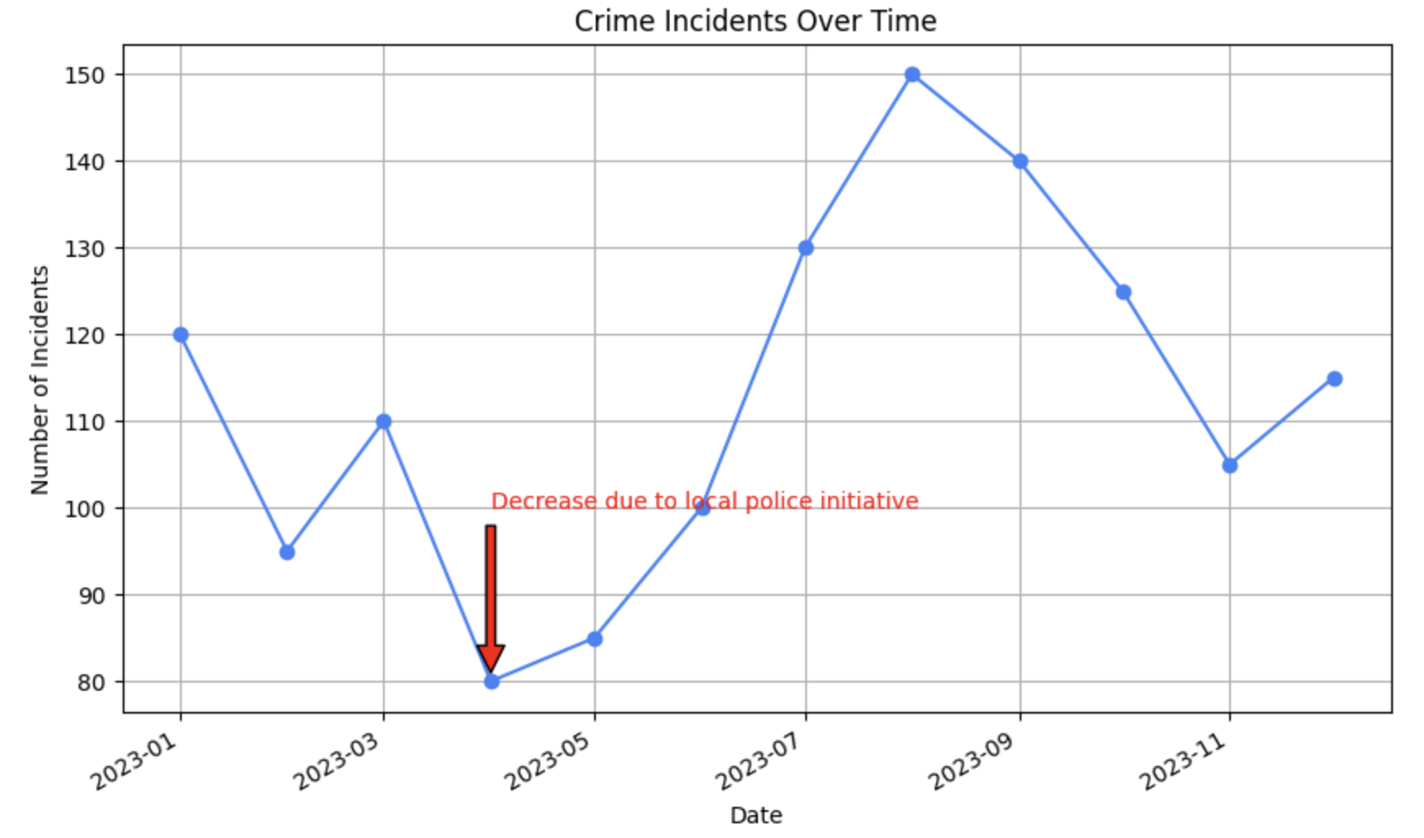

## **4.1.3. Population and Demographics**

To give a full picture of the district's residents, a variety of demographic charts will be utilized.

1. **Population Pyramid (Age & Gender Distribution):**

This chart combines the breakdown of residents by **age group** with the **split between male and female populations**. Each horizontal bar corresponds to an age group (e.g., 0–6, 6–15, 15–18, 18–27, 27–45, 45–55, 55–65, 65+). Bars extending to the left represent the male population, while bars extending to the right represent the female population. The combined shape provides an intuitive view of the district’s demographic structure, highlighting which age groups are more prominent and how evenly they are split by gender.

**Chart Title:** *"Population Pyramid (District Name)"***X-Axis Label:** *"Population"***Y-Axis Label:** *"Age Group"***Legend:** Distinguishes between “Male” and “Female.”  
**Tooltip (interactive setting):** On hover, display:*"Age Group: [Age Range]","Gender: [Male/Female]","Population: [Number of people]", "Percentage of Total Population: [%]"*

**Highlighting:** In comparison mode, pyramids from two districts can be aligned side-by-side, making it easy to see differences in both age structure and gender distribution at a glance.

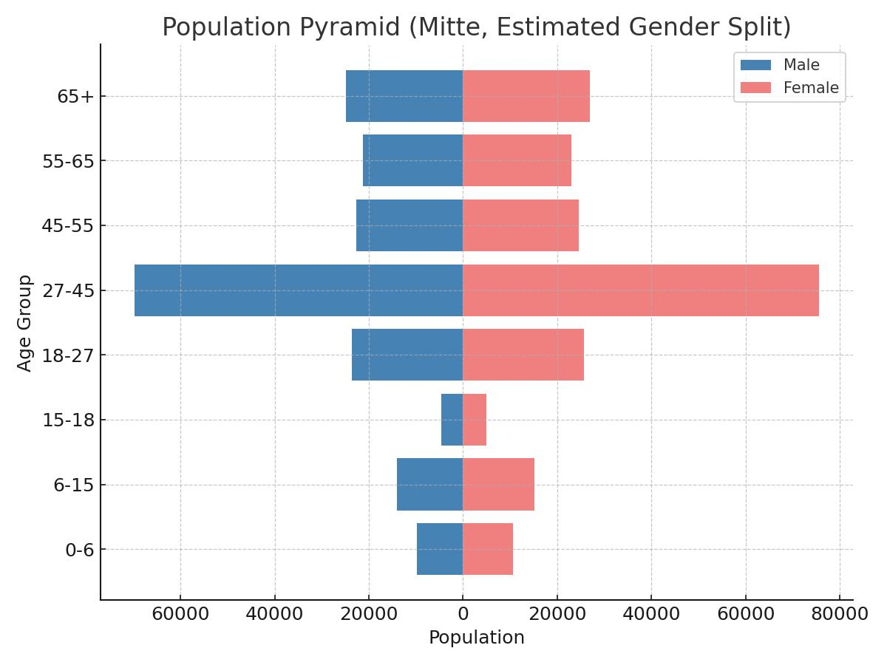

1. **Stacked Bar Chart (Population Over Time):** A stacked bar chart can be used to show **population changes over time**, broken down by key demographics like age or nationality, providing insight into how the district is evolving.

**Chart Title:** "Population Change by Demographics"

**X-Axis Label:** "Year"

**Y-Axis Label:** "Population"

**Description:** This chart illustrates how the total population of the district has changed over time, with the bars broken down by **key demographic segments like age groups or nationalities**.

**Tooltip:** On hover, show "Year: [Year]", "Demographic: [Group]", and "Population: [Number]". The total height of the bar will show the overall population for that year.

**Highlighting:** The use of different colors for each segment allows users to quickly see how the composition of the population is shifting over time.

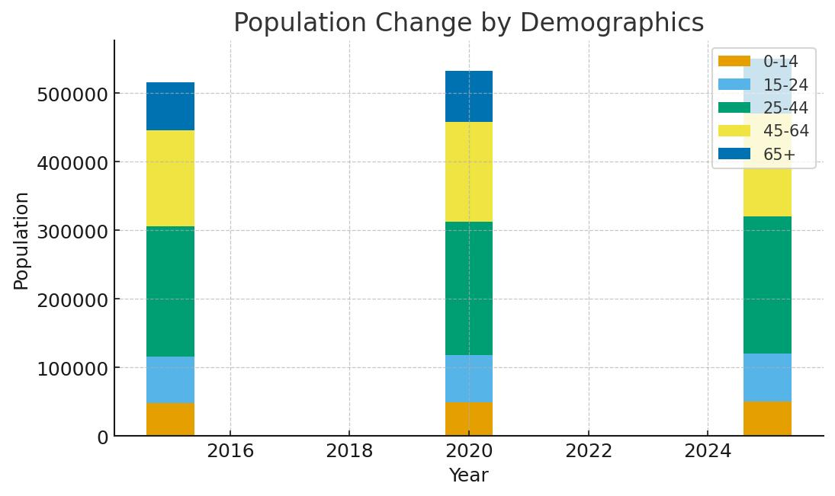

### 

### 

### 

### **Stacked Bar Chart - Germans vs. Foreigners**

This chart visualizes the **proportion of Germans and foreigners across the districts** using a 100% stacked bar design.

* **Purpose**: Highlight relative composition rather than absolute numbers, making it easy to compare districts at a glance.
* **Design Choices**:  
  - Bars are normalized to 100%, ensuring consistent scale across districts.  
  - **Percentage labels** are placed inside each segment for immediate clarity.  
  - Distinct colors differentiate Germans and foreigners, supported by a legend.
* **User Experience**: This layout emphasizes **proportions**, ensuring smaller groups remain visible regardless of population size.

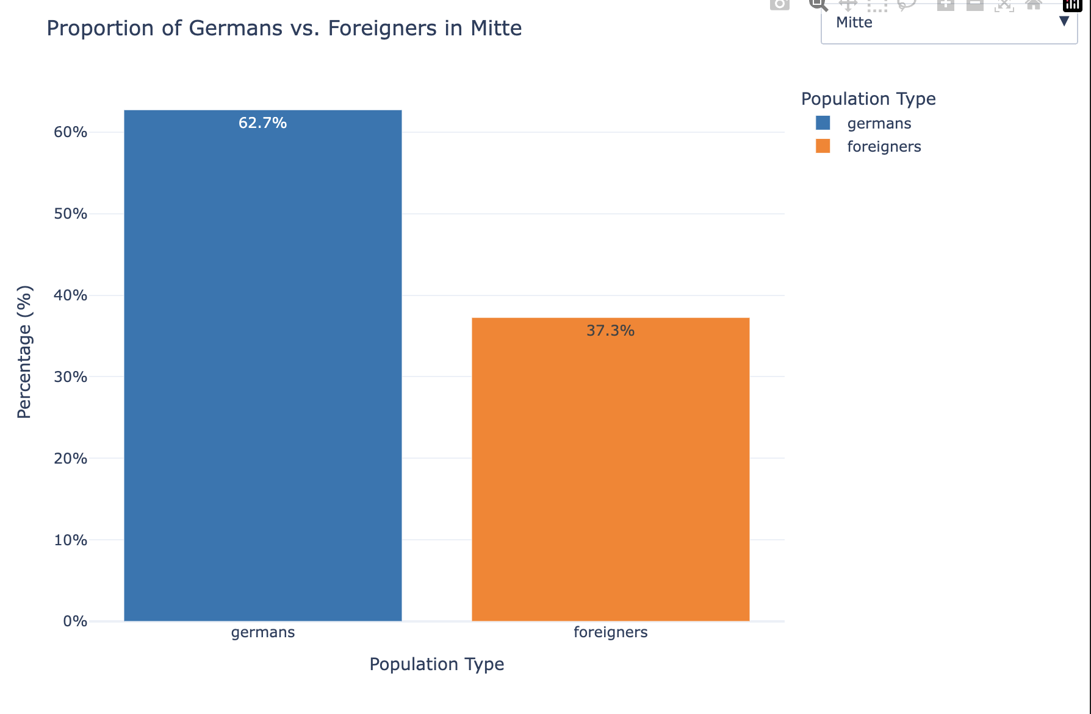

## 

## **4.1.4. Transport and Mobility**

This section will focus on the accessibility and density of public transportation within the district.

1. Can I access it quickly? **Table or iconography**
   1. Distances from landmarks like Alexanderplatz, Hauptbahnhof, Charité, BER - calculated by the median of the sum of distances of the centroid of the district and 3 or 4 other points. VIZ: Probably a table dividing reach time by public transportation, car, and bike and walk when respecting limits.
2. How well covered am I?
   1. Median of distances from listings table (apartments) to transportation stops. It can also be compared to populational grid to find the percentage of people living at those distances.

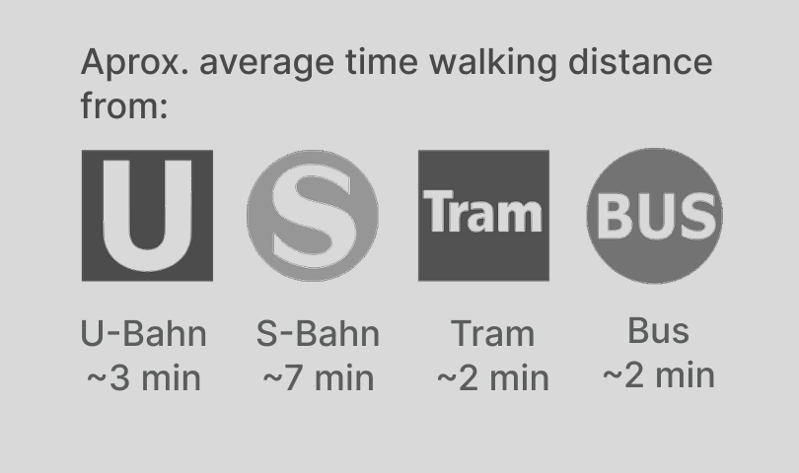

## 

## **4.1.6 Key Amenities Count**

This chart visualizes **resource availability** across districts by showing the distribution of selected amenities (schools, hospitals, parks, pools, and transportation).

* **Chart Title**:  *Amenities per Berlin District*
* **X-Axis Label**: *Amenity Type* (e.g., "Schools", "Hospitals", "Parks")
* **Y-Axis Label**: *Count*  
  - Amenity Type: [Type]  
  - Count: [Number]
* **Highlighting Rules**:  
  - In a **single-district view**, use one consistent color for all amenities to emphasize total resource availability.  
  - In a **comparison view across districts**, apply distinct colors for each district to make differences immediately visible.
* **Design Choices**:  
  - Grouped bars provide clear side-by-side comparison within districts.  
  - Vertical tooltips summarize amenity counts without cluttering the chart.
* **User Experience**: This chart focuses on **absolute counts of key amenities** to communicate resource availability per district. It supports both detailed inspection (via tooltips) and comparative analysis across districts.

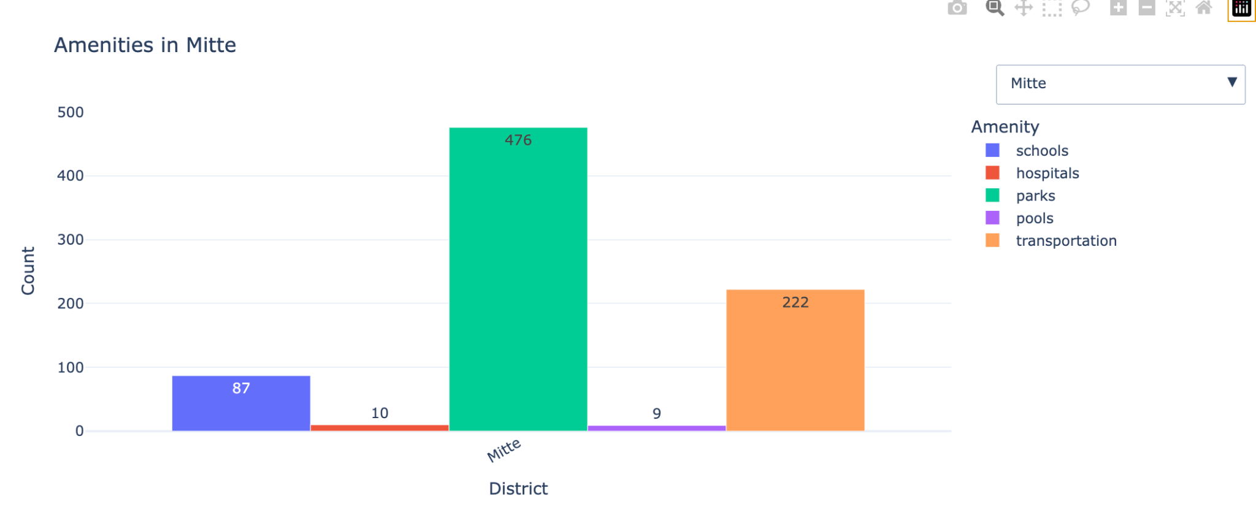

1. **Grouped Bar Chart (Amenity Types):** A grouped bar chart can compare the counts of different types of amenities (e.g., public vs. private schools, or general vs. specialized hospitals), offering a more granular view.

**Chart Title:** "Amenity Breakdown by Type"

**X-Axis Label:** "Amenity" (e.g., "Schools", "Hospitals")

**Y-Axis Label:** "Count"

**Description:** This chart provides a **granular comparison of different types of amenities**. It helps users see not just the total count, but the specific composition (e.g., how many schools are public versus private).

**Tooltip:** On hover, show "Amenity Type: [Public/Private]", "Amenity: [Schools/Hospitals]", "Count: [Number]".

**Highlighting:** Use different shades or colors within each group to distinguish between the sub-categories, such as "Public" and "Private."

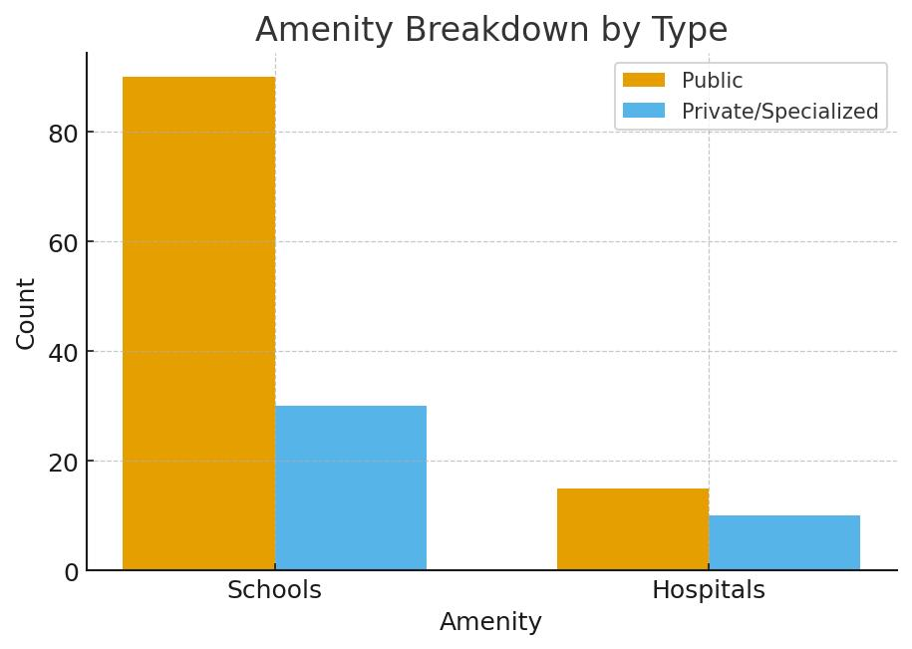

1. **Map with Data Points (Interactive):** An interactive map of the district with pins or icons marking the **specific locations of schools and hospitals**. Hovering over the icons reveals more details, such as the name and type of the institution. This provides a clear spatial context.

**Map Title:** "Location of Amenities"

**Legend:** A simple legend to explain the icons used for different amenities (e.g., a school icon, a hospital icon).

**Tooltip:** On hovering over an icon, display the name of the institution (e.g., "Charité - Universitätsmedizin Berlin"), its type, and its address.

**Highlighting:** Clicking on a specific amenity icon could highlight its details in a separate information panel.

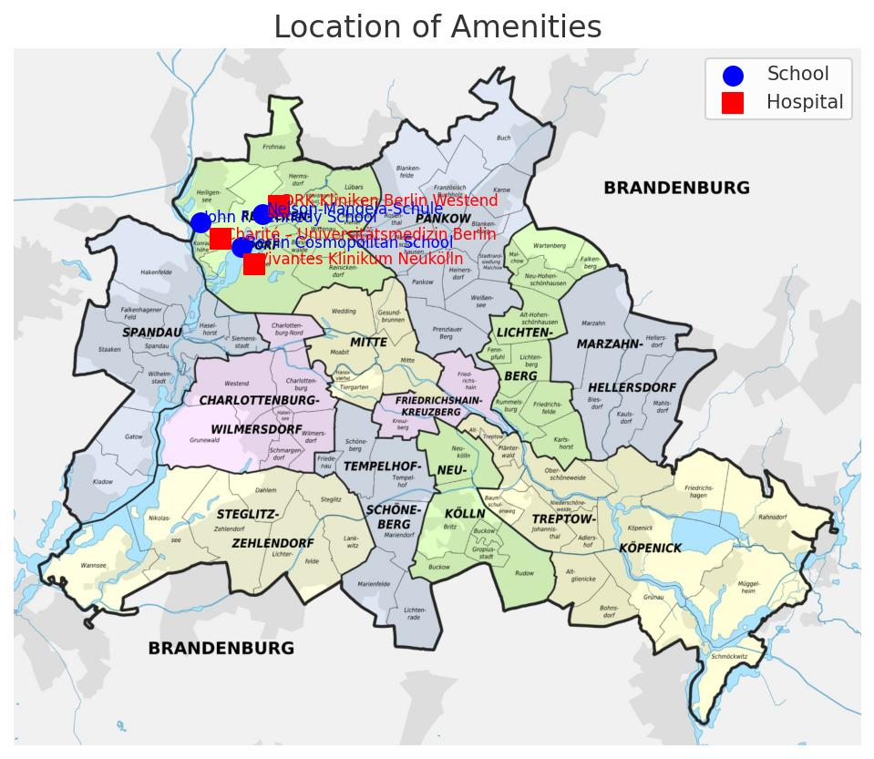

## **7. Styling & UX Guidelines**

* **KPI Cards:** compact, consistent, icon + number + label.
* **Map:** hover highlight, selected outline.
* **Safety Score:** color-coded (green safe → red unsafe).
* **Charts:** consistent theme, legends, axis labels.
* **Device focus:** Desktop (primary), Tablet (secondary).